Resistors in Series:

When resistors are connected one after the other in a single row they are connected in series.

RI-100 Ω R2=200 Ω R3=300 Ω



B

If the three resistors connected in series RI, R2 and R3 have the values of 100 Q, 200 Q and

300 Q respectively, the total resistance between the points A and B can be found using the rule



R 100 + 200 + 300 = 600 Ω

Q.l Find the total resistance in the following circuits:

Rl=50 Ω R2=150 Ω R3=70 Ω

  
50+150+70=270Ω

# (b)

Rl=1.5 kΩ R2=3.3 kΩ R3=O.5kΩ

  
1.5+3.3+0.5=5.3kΩ

(c)

Rl=600 Ω RF2.2k Ω R3=800 Ω

600+2200+800=3600Ω



B

Q.2 Calculate the total resistance if five resistors of the values 38 Ω, 158 Ω, 1.3 k Ω, 230 Ω and 1.2k Ω are connected in series. 38+158+1300+230+1200=2926Ω

Q.3 When three resistors RI, R2 and R3 are connected in series, the total resistance RT is 650 Ω. If RI is 170 Ω and R2 is 230 Ω find the value of the R3 resistor. 650=170+230+R3, 650-400=250, R3=250Ω

Q.4 When three resistors RI, R2 and R3 are connected in series, the total resistance RT is 3.5 kΩ. If RI is 850 Q and R2 is 1.5 kΩ find the value of the R3 resistor. 850+1500=2.35k Ω 3500-2350=1150 Ω

Resistors in Parallel:

When each resistor is connected to other at both ends they are connected in parallel.

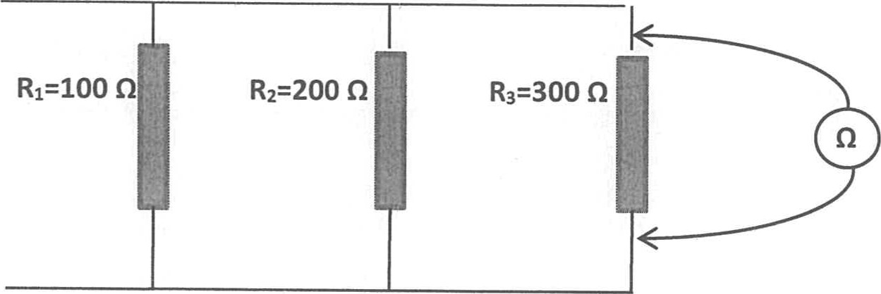

If the three resistors connected in series RI, Rz and R3 have the values of 100 Q, 200 Q and

300 Q respectively, the total resistance between the points A and B can be found using the rule

|  |  |
| --- | --- |
| 1 | = 1 + 1 + 1 |

|  |
| --- |
| RT = ( RI-I + Ril + R3 1 ) 1 |

OR use

RT = (100-1 + 200-1 + 300-1) -1 = 50 Q

 We can see that the resistance decreases when connected in parallel. Q.l Find the total resistance in the following circuits: (a)

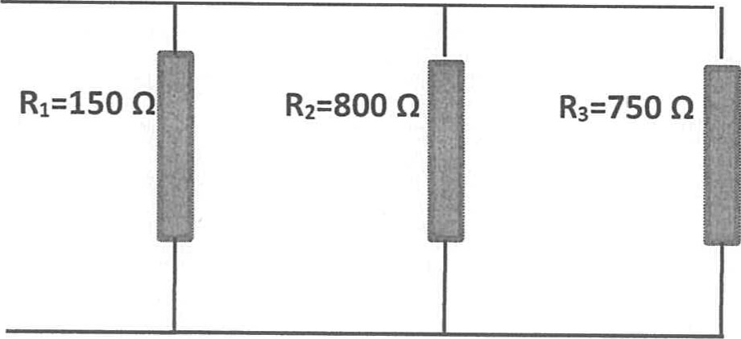 RT = ( RI-I + Ril + R3 1 ) 1

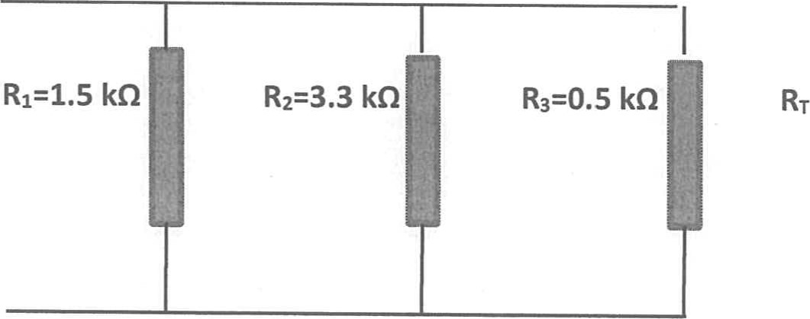

(b)

=

(

RI-I

+

+

R3

1

)

1

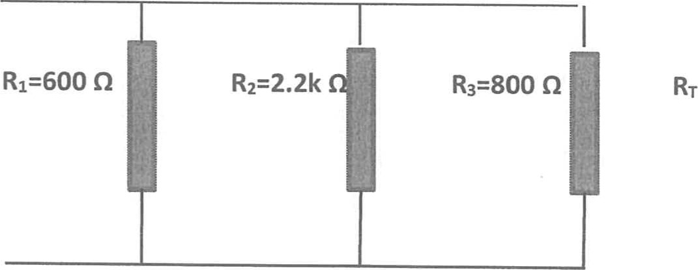

=

(

RI-I

+

Ril

+

R

3

1

)

1

Q.2 Calculate the total resistance if four resistors of the values 158 Q, 1.3 k Q, 230 Q and 1.2k Q are connected in parallel.

# RT = ( RI-I + Ril + R3-1 +

Q.3 Calculate the total resistance if three resistors of the values 600 Q, 0.3M Q and 1.2k Q are connected in parallel.

## RT = ( RI-I + Ril + R3-1

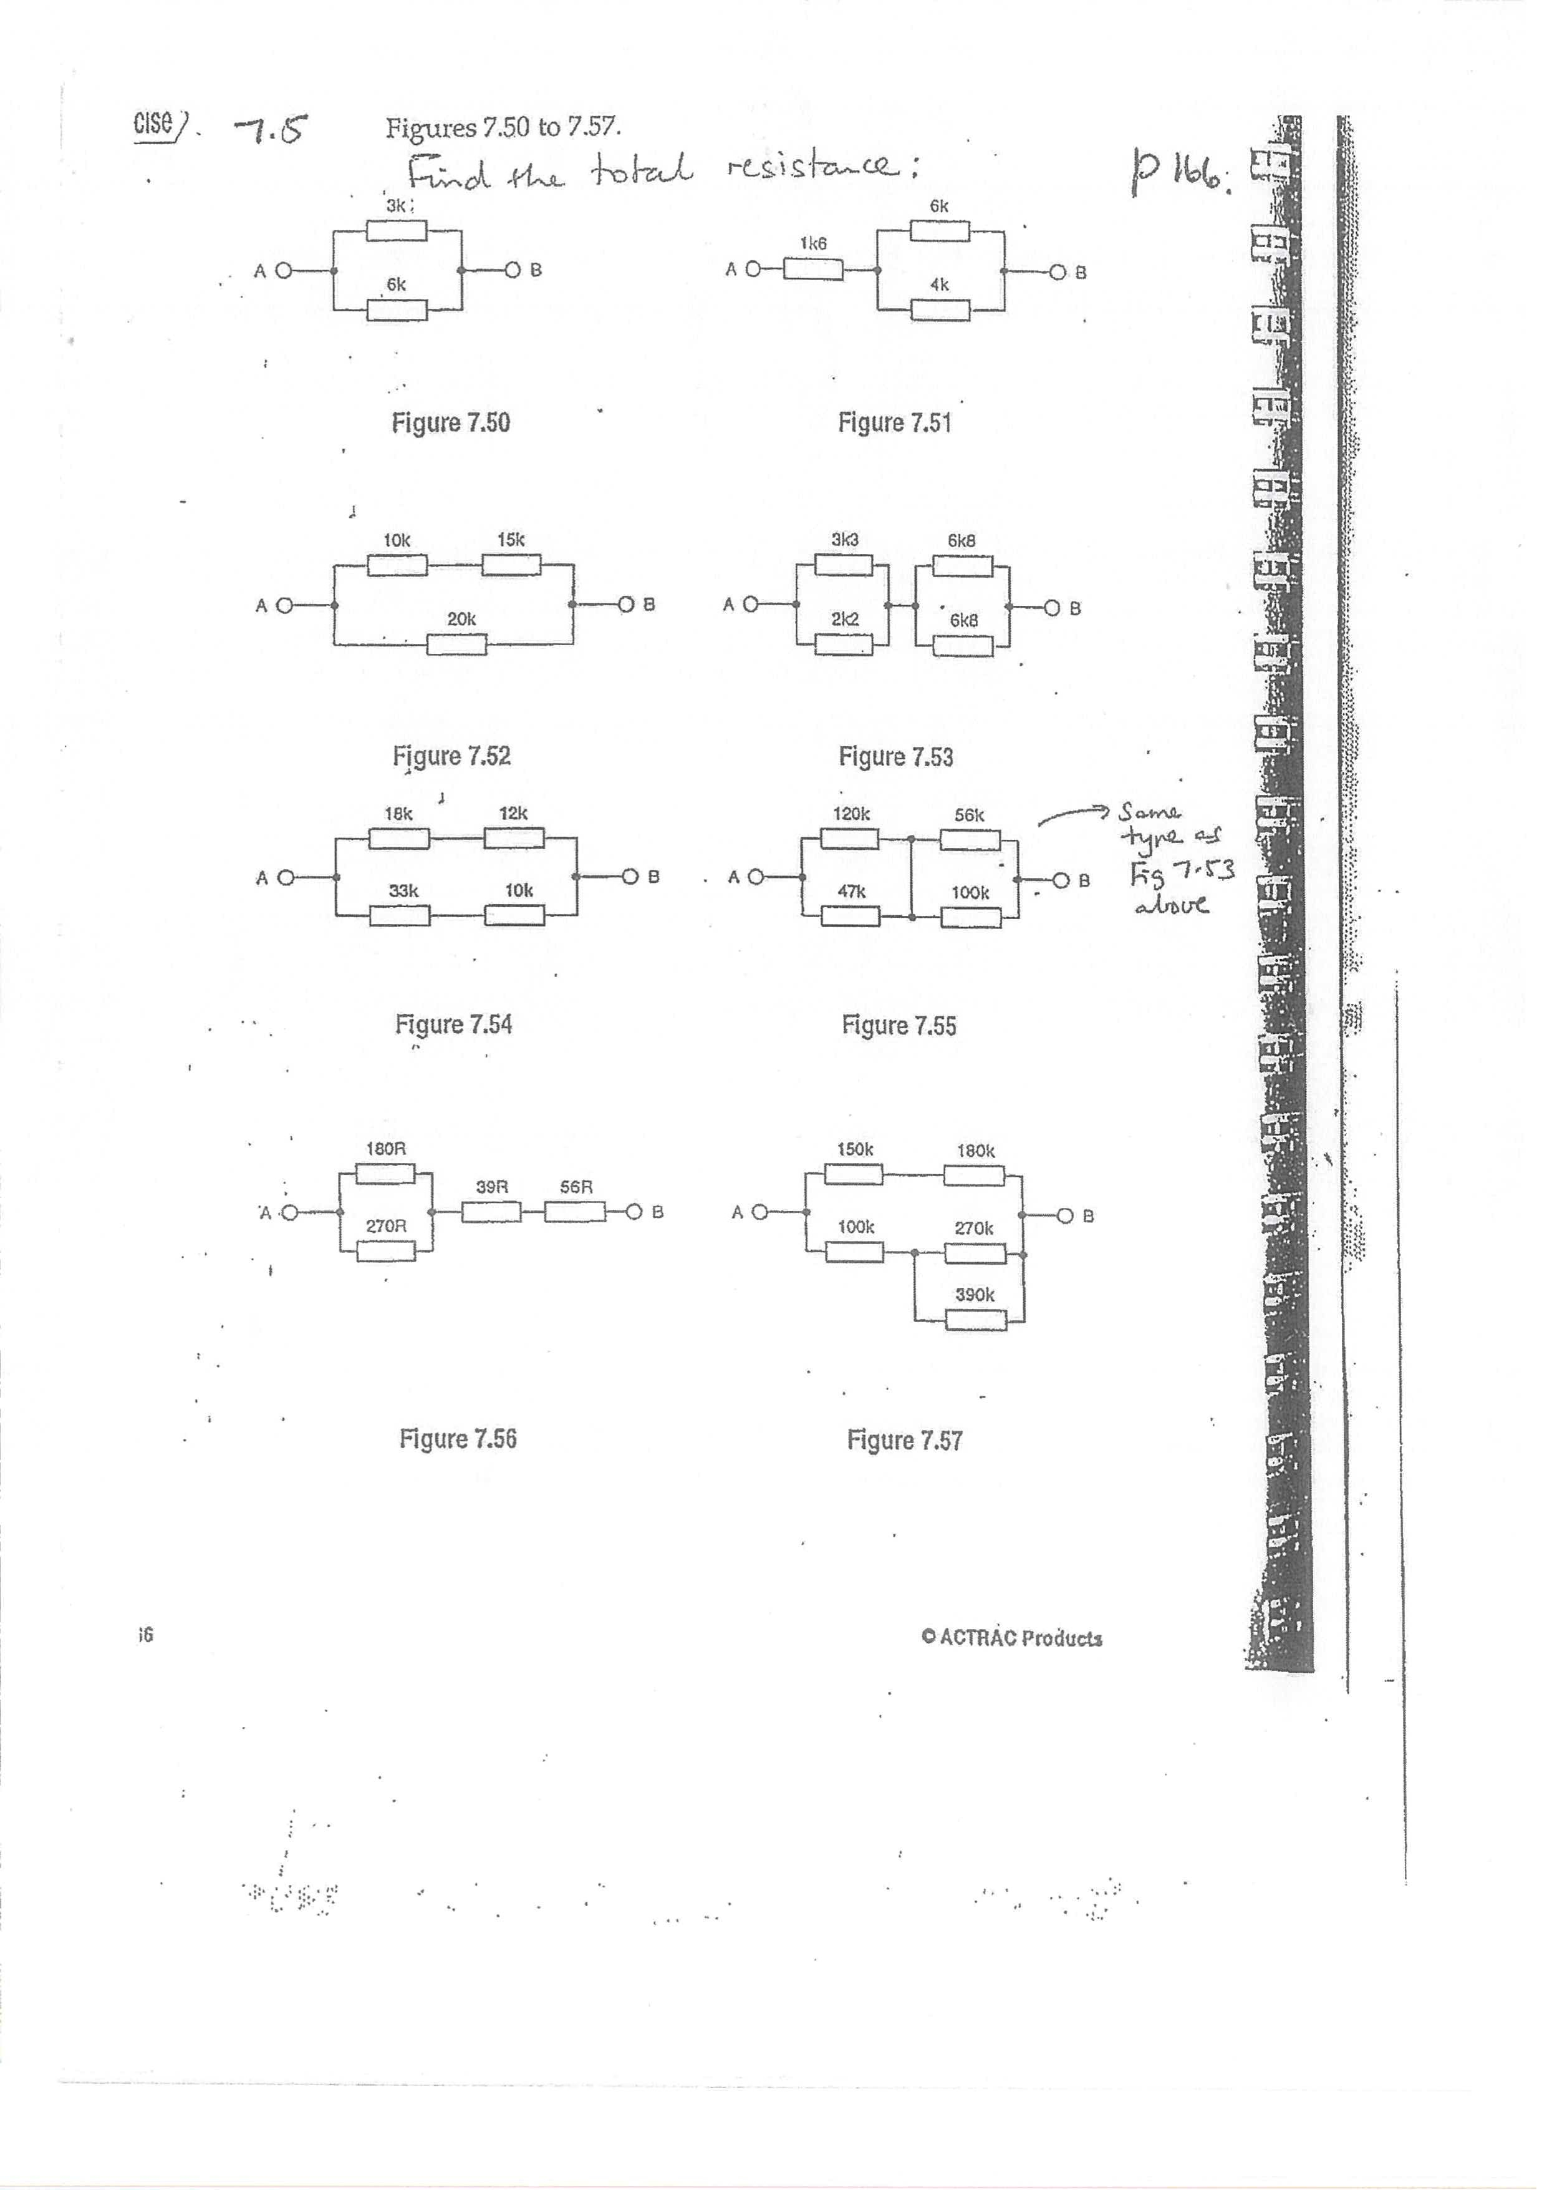

i6

